# Calculating Financial Returns - Plotting Returns

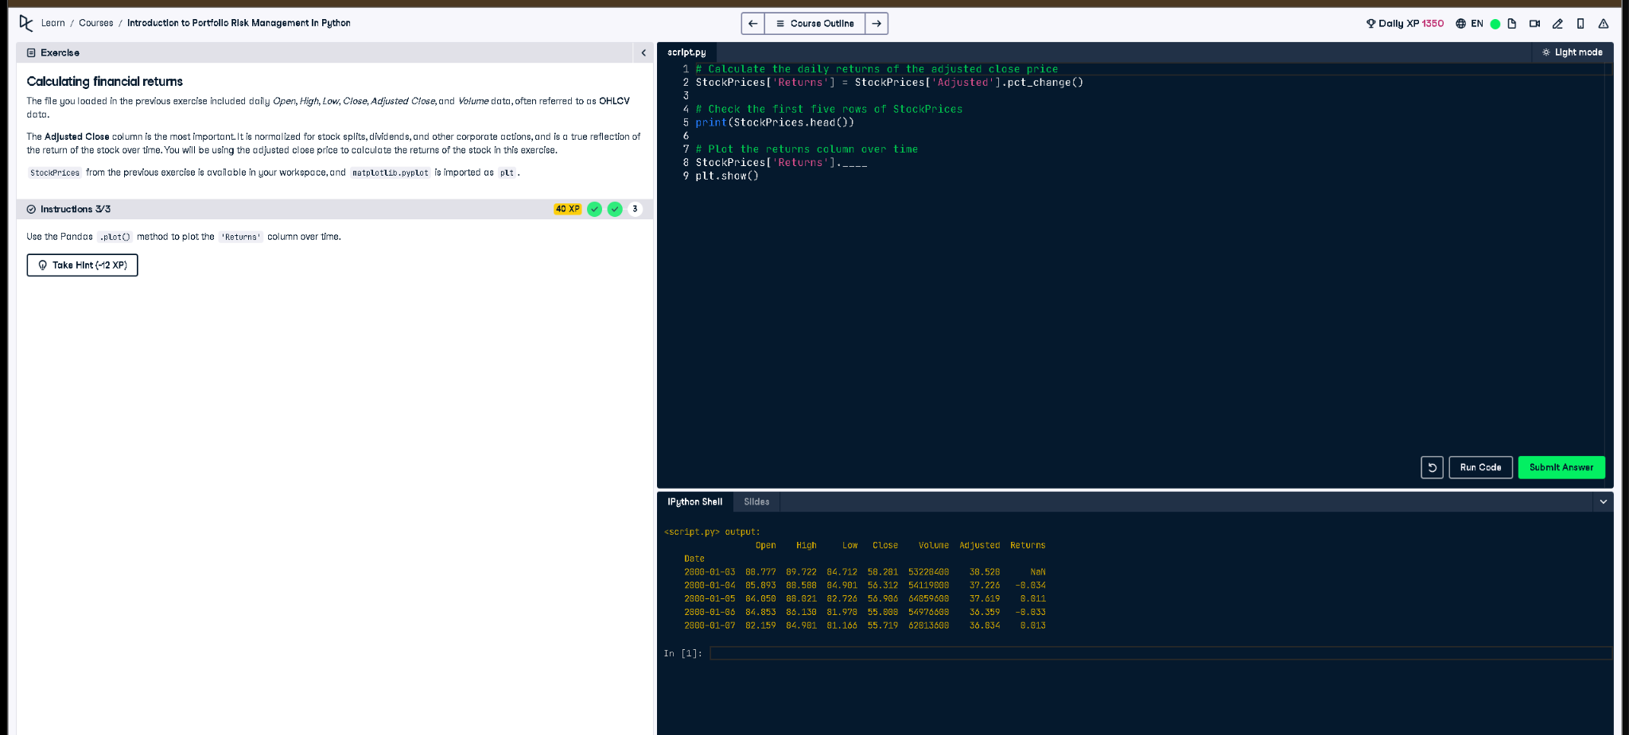

## Python Code:

# Calculate the daily returns of the adjusted close price  
StockPrices['Returns'] = StockPrices['Adjusted'].pct_change()  
  
# Check the first five rows of StockPrices  
print(StockPrices.head())  
  
# Plot the returns column over time  
StockPrices['Returns'].plot()  
plt.show()

## Explanation (in simple words):

This code calculates daily stock returns using the adjusted close price. It finds the percent change between days with .pct_change(), adds the result to a 'Returns' column, shows the first five rows with .head(), and then plots those returns over time using the Pandas plot method and matplotlib.